Planeshift Preview: Phyrexian Scuta
Brian Kibler
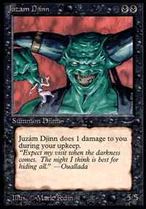
Since the early days of Magic, every time a new set comes out, excited players clamor on about how this or that creature is "the new Erhnam" or "the new Juzam." The Arabian Nights Djinns, it seems, have become the standard by which all creatures are measured, and perhaps for good reason. In their time, there was not a better deal to be found than this pair of undercosted ground-pounders, and they found their way into countless tournament decks, crushing all opposition in their path. Over the years, new creatures have stepped up to take on the mantle of these Magic legends and have met with varying degrees of success. The newest contender for the title, Planeshift's Phyrexian Scuta, is sure not to disappoint.
Possibly the closest approximation to the original Juzam Djinn ever to see print, Phyrexian Scuta is large and in charge. With the potential of being a 5/5 for four mana, the Scuta joins Blastoderm and Jade Leech as one of the biggest boys on the block. The new kid has one significant advantage over his peers, though; he's BLACK. Much like the edge the Juzam of old had over his forest-dwelling counterpart, the most immediate implications of this is that the Scuta is in the same color as Dark Ritual, and thus has the potential to hit the board on turn two. While green mages have access to mana acceleration in the form of Elves and Birds, these are vulnerable to disruption and don't provide quite the same burst of speed as the Ritual, leaving them a turn slower. That turn can mean a window for the opponent to have Counterspell mana open, or even just give you one less attack phase before they can find an answer. Either way, Ritual-Juzam has long been a frightening possibility in Type 1 tournaments, and Phyrexian Scuta brings that terror back to Standard with a vengeance.
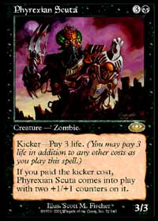
Even barring the use of Dark Ritual, the fact that the Scuta is black is a tremendous boon. Black creatures - particularly large black creatures - are notoriously difficult to remove, as the majority of efficient targeted removal, such as Terror, Snuff Out, and Vendetta, is useless against them. Additionally, unlike Blastoderm and Jade Leech, Phyrexian Scuta will never fall victim to the an untimely Perish. As a 5/5, the Scuta is out of the range of nearly all damage-based removal as well, with Assault, Urza's Rage, and Rhystic Lightning all falling short of getting the job done. In Standard, barring global removal effects and blocking, the only commonly played way to get the Scuta off the table without conceding card advantage is Ghitu Fire, at the hefty cost of six mana. Terminate will do the job, too - but we'll have to see how well played it is. By the time your opponent has enough mana available to Fire, the Scuta can easily have finished the job.
Beyond its resemblance to the big bruiser of Arabian Nights, the most obvious comparison to make is to the Scuta's Urza's Block cousin, the Phyrexian Negator. The most recent of the other Juzam impersonators, the Negator has the advantage over the Scuta in terms of casting cost, with its ability to be Ritualed out on the first turn an enormous point in its favor. Despite this, however, the Scuta may well be a better option for the current Standard environment. The Scuta's drawback - losing three life as part of its kicker cost - is marginal in a creature-heavy environment compared to the Negator's permanent sacrificing effect. When damage-based removal and trips to the Red Zone are common, a one-time investment of three life is far less detrimental than sacrificing permanents every time your creatures are dealt damage. There is little worse than a first turn Ritual-Negator being met by an Assault or similar spell, and while the Scuta has to wait until turn 2 to come and play, it takes a lot more to knock him out of commission.
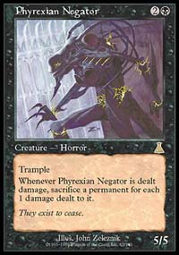
Despite his increased resilience, the Scuta does have his disadvantages, the most glaring of which is the fact that his added bulk comes from a kicker cost. While this gives the card some measure of versatility, as it can be played without life payment when all that's needed is a 3/3 body or when three life is too much to spare, it also makes the Scuta a dangerous proposition against aggressive decks with counters or bounce effects. As the cost to beef up the Scuta is a kicker payment rather than a comes-into-play effect, the life is lost even if the spell is countered - getting your kicked-up Scuta Undermined is painful, to say the least, and fighting through a barrage of Withdraws and Wash Outs seems like it would be nothing but a losing proposition. Perhaps most significant is the fact that a Scuta removed by Parallax Wave will return to play as a lowly 3/3 when the Wave fades out, making paying the kicker on a Scuta a much less attractive option against rebel decks than it otherwise would be.
Regardless of all of this, Phyrexian Scuta still stands to make a significant impact on the Standard format and, perhaps, beyond. Unlike its Arabian ancestor, the Scuta has only one colored mana in its casting cost, and this, along with the proliferation of multicolored decks in the wake of Invasion, allows for the possibility that the Scuta will make an appearance outside Suicide Black style decks, which also may experience a renaissance of sorts with the coming of this newest in a long line of Juzam imposters. Aggressive black decks - and black decks in particular - have been the subject of much scorn among top players of late, and the absence of a single Swamp in the top eight of the recent Pro Tour Chicago seems to be provide good reason for this. Enormous, undercosted creatures tend to breathe life into underplayed colors, however, and it will be interesting to see what kind of showing black decks with the Scuta make in Tokyo and the championship season this summer. Regardless of whether they come to play on turn 2 off a Dark Ritual or on turn 3 with a little help from Birds of Paradise, Phyrexian Scuta promises to be a force to be reckoned with for many tournaments to come.

